Ashley Hill Multi Academy Trust

Weekly Spelling Homework

Year 3

Name: ____________________

Encourage one another and build each other up
1Thessalonians 5:11

Parent Instructions:

Children receive 10 spelling words per week. Please ensure that they are practised daily. To help with daily learning of spelling words there are apps that children can access at a small cost.

Children will have their spelling test each Friday. The format for asking spelling words is by putting the word in context, see the example below.

Adult/teacher:

The word is fish
The fish was a bright blue colour.
The word is fish

If your child is struggling to remember how to spell some of the common exception words, try these mnemonics to help them learn the words.

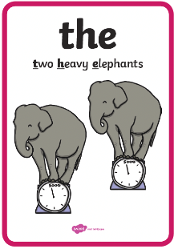 | 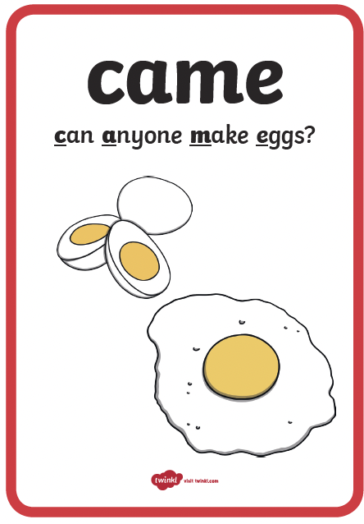 | 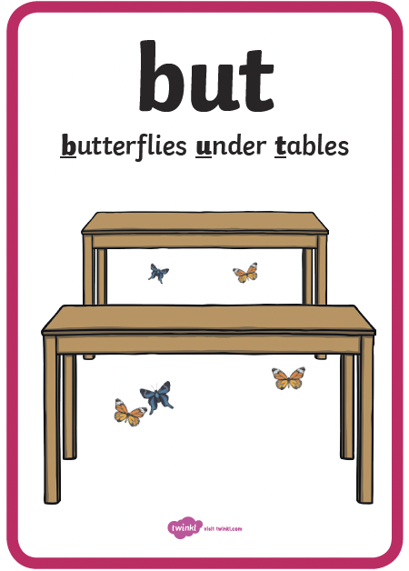 | 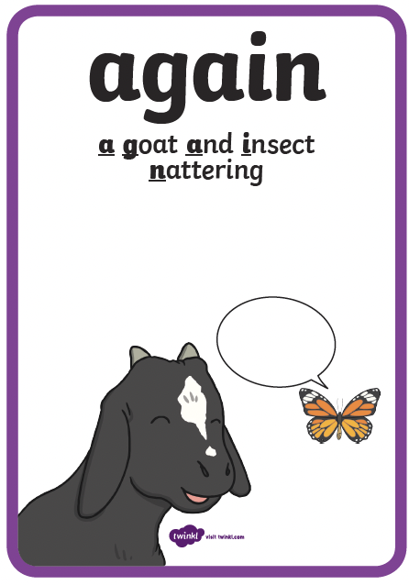 | 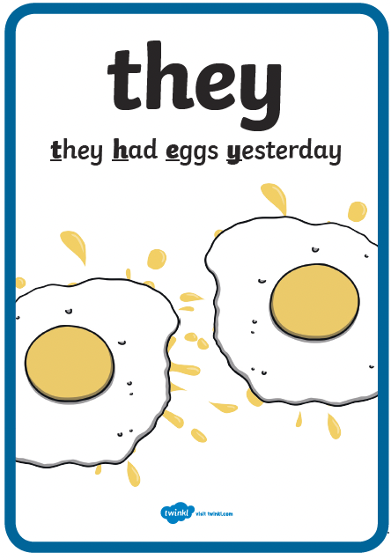
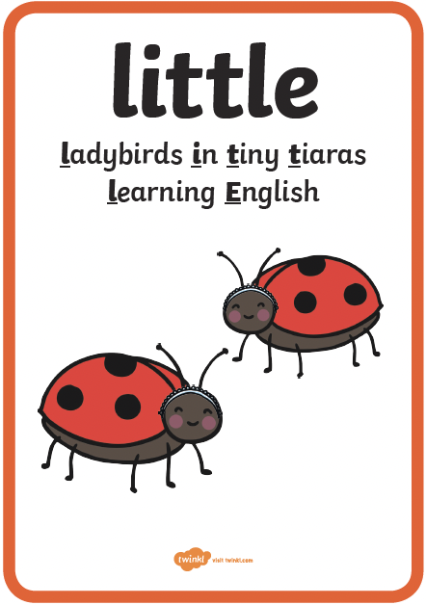 | 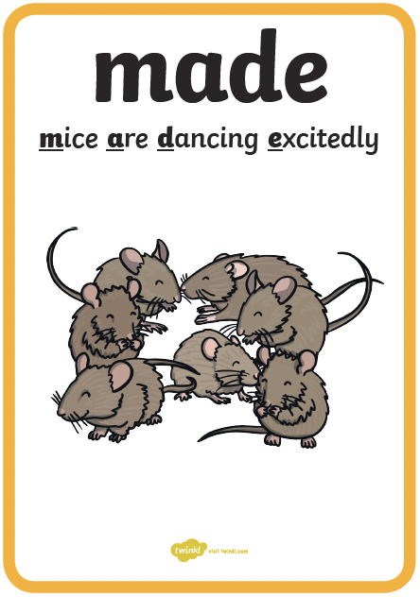 | 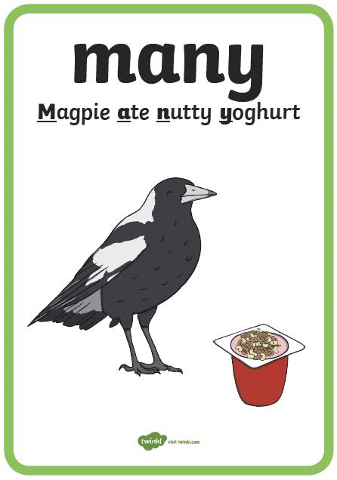 | 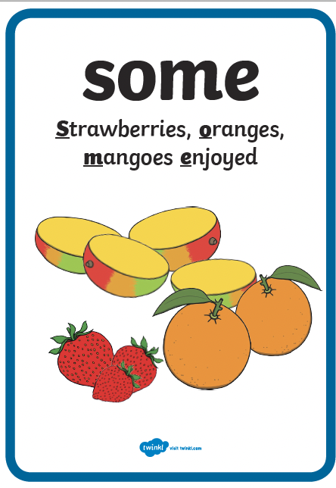 | 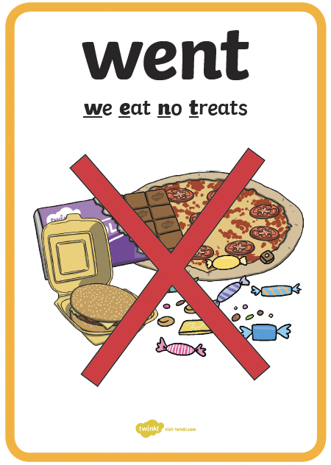
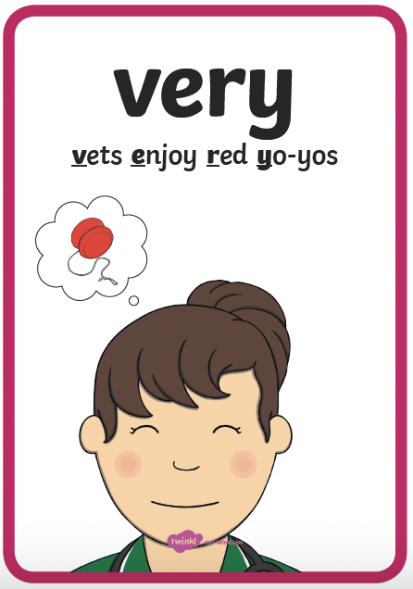

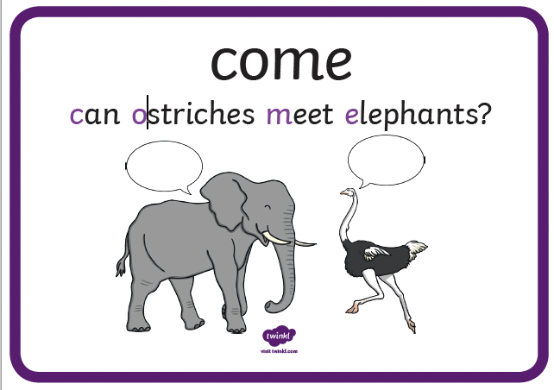 | 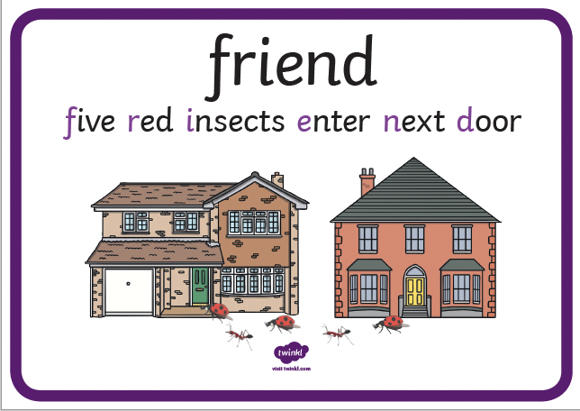 | 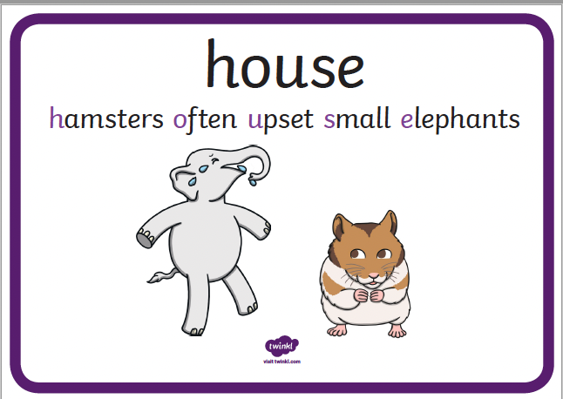 | 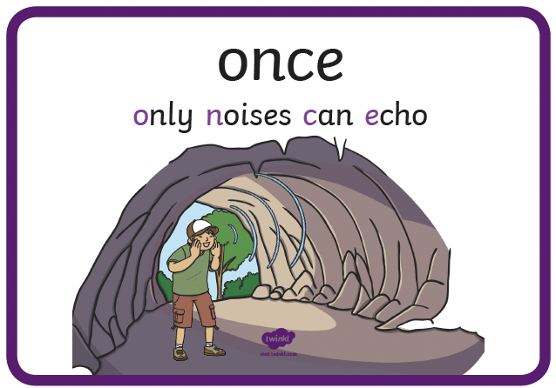
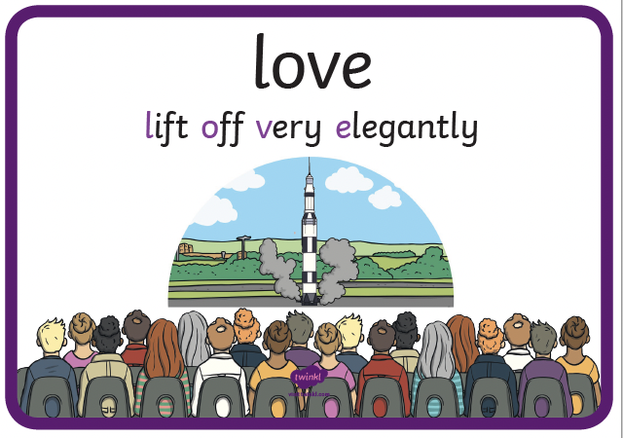 | 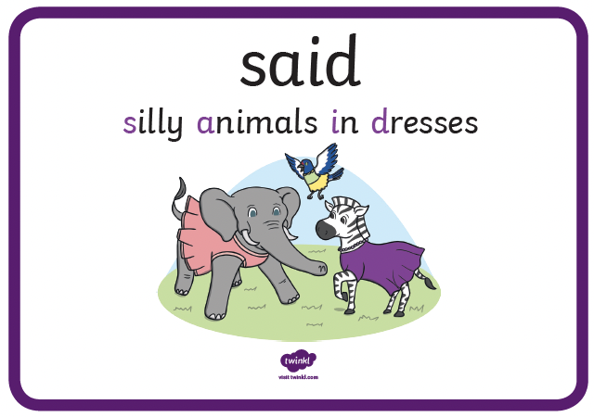 | 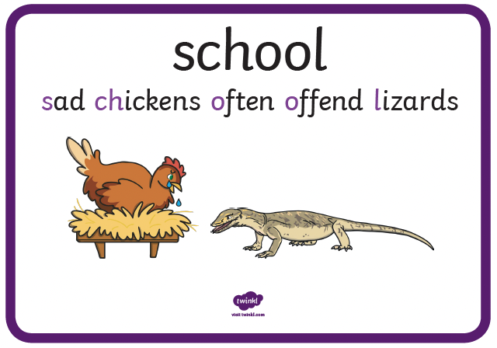 | 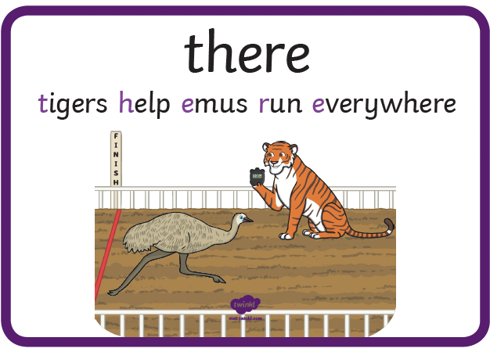
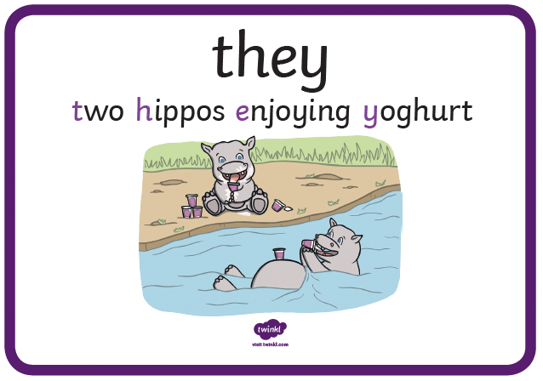 | 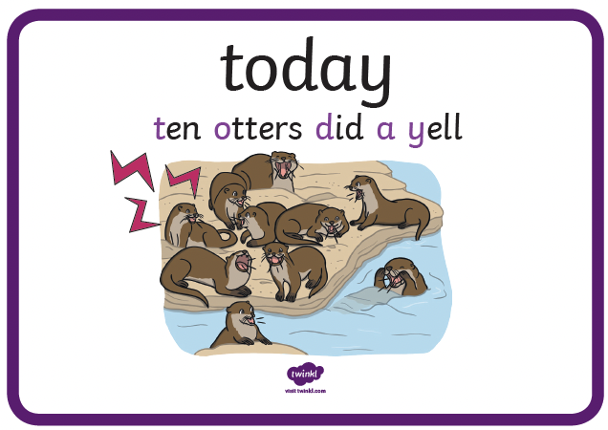 | 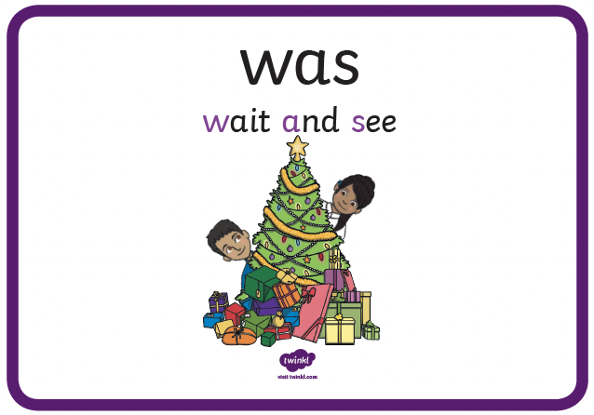 | 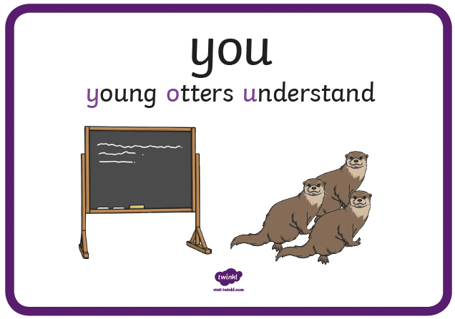

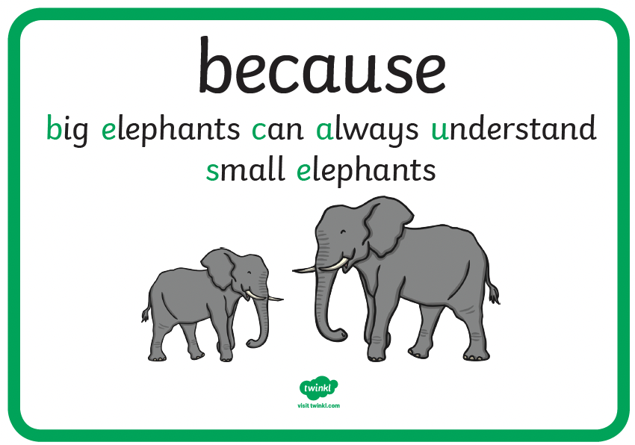 | 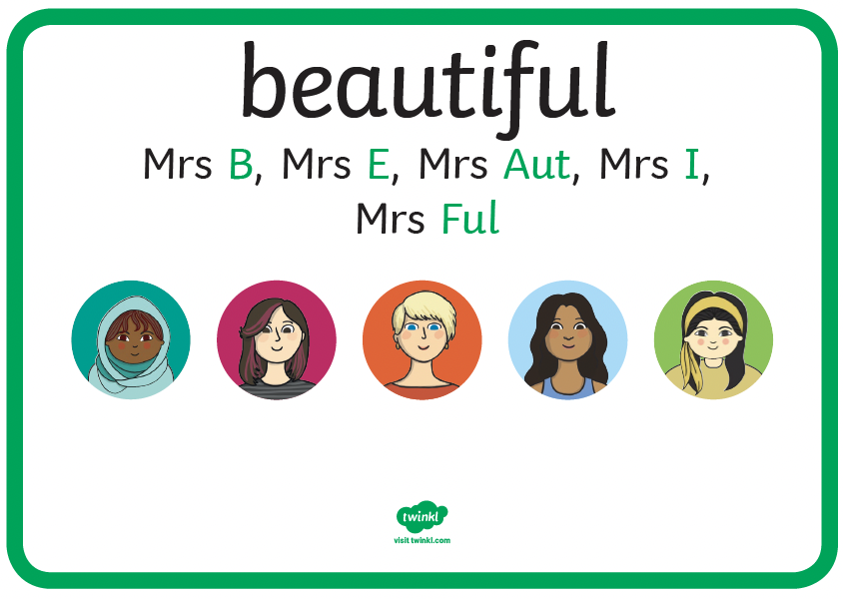 | 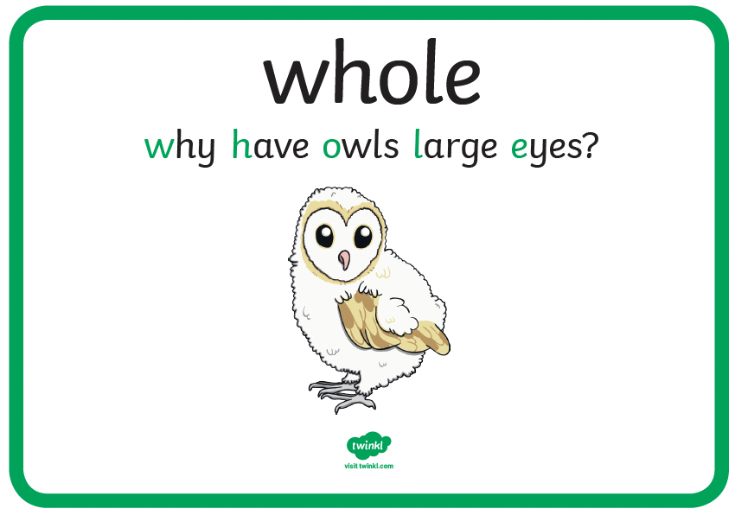 | 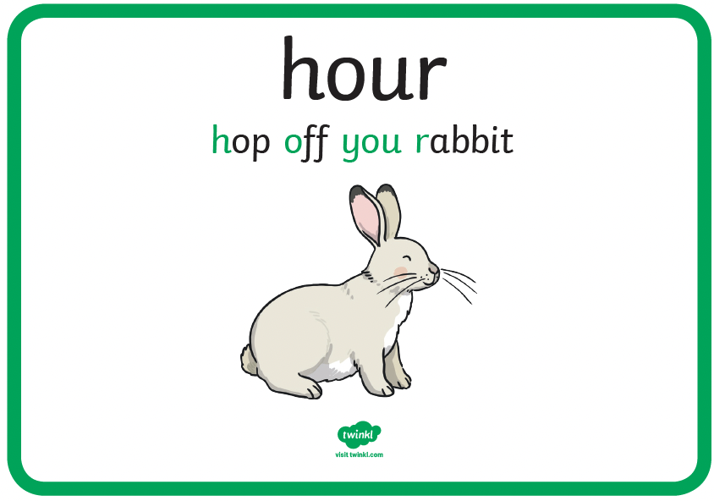
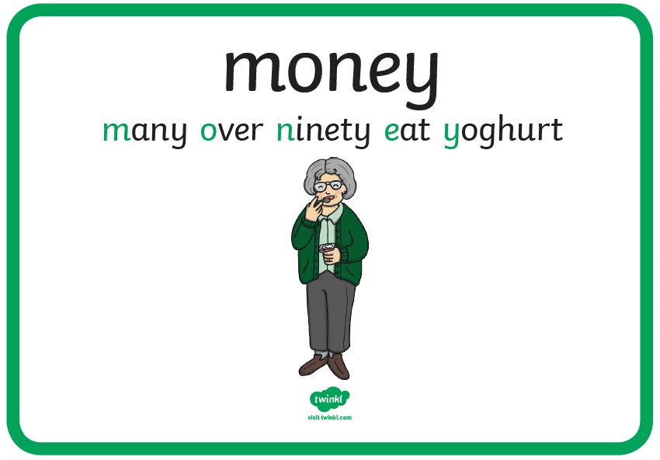 | 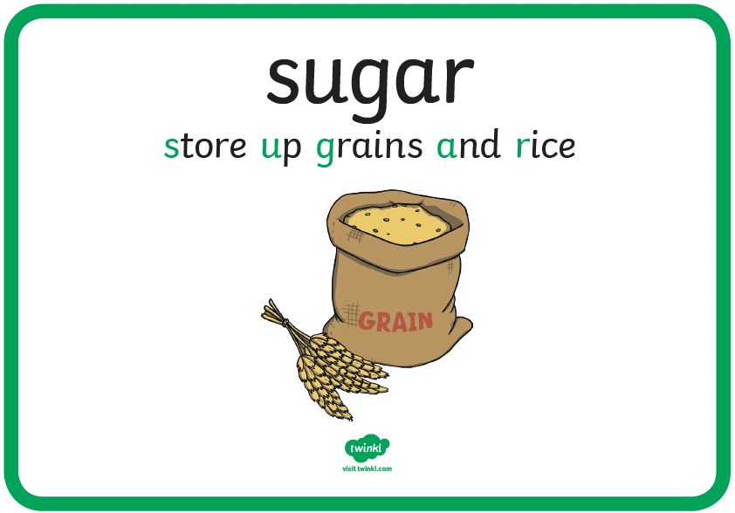 | 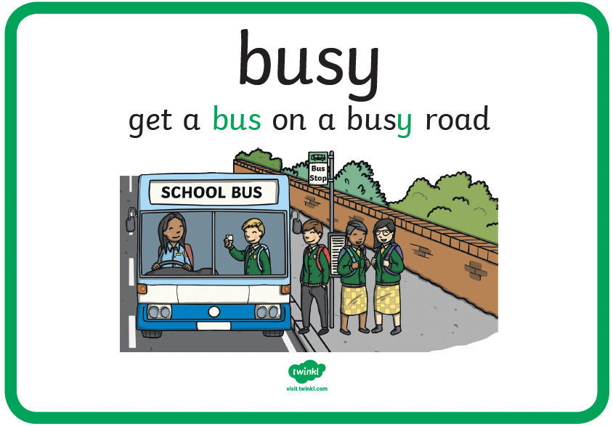 | 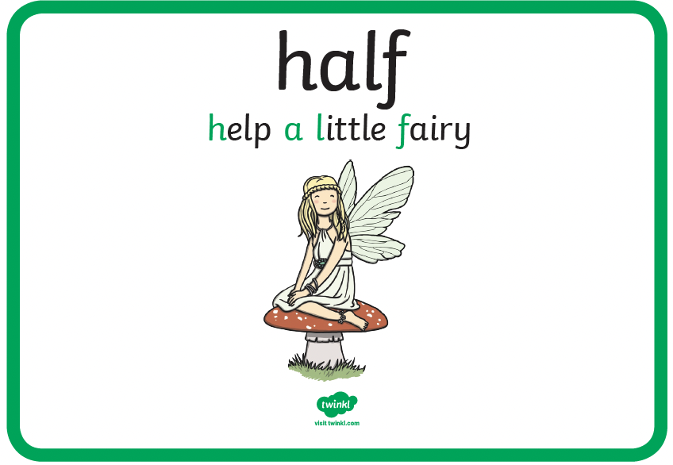
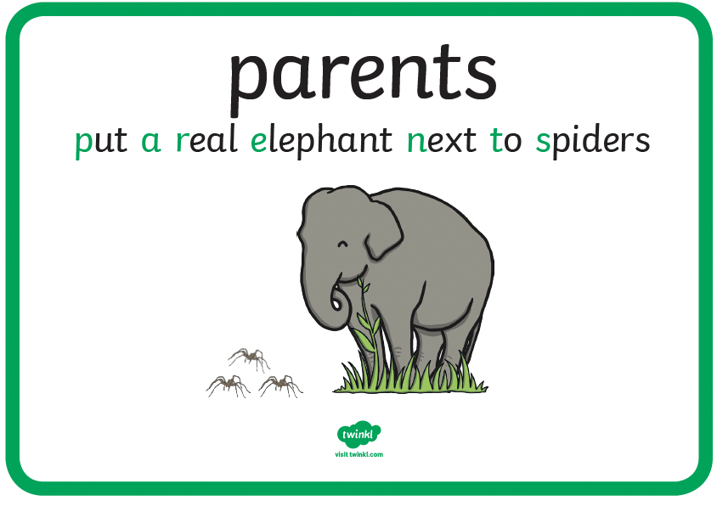 | 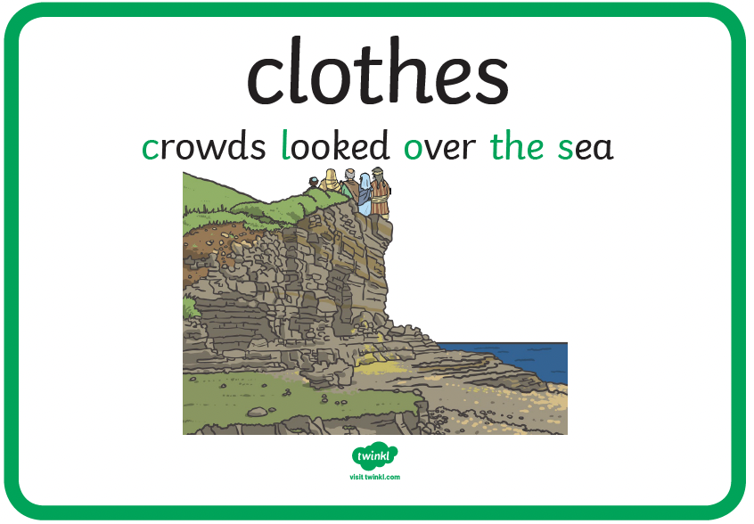 | 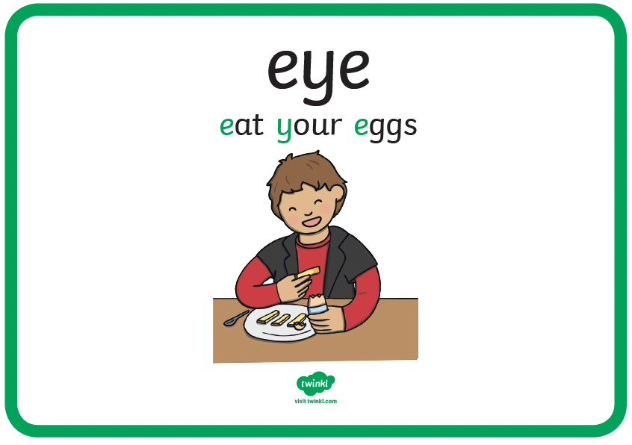 | 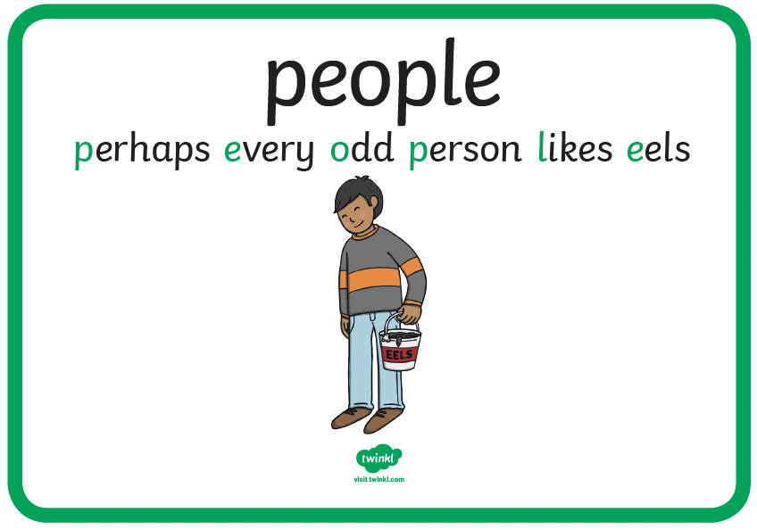

Autumn
Week 1 – 8th September - Adjective suffix
 | Monday | Tuesday | Wednesday | Thursday
accidentally
actually
probably
caught
consider
successful
longest
beginner
grateful
gardener

Week 2 – 15th September - /i/ spelled with y
 | Monday | Tuesday | Wednesday | Thursday
naughty
disappear
fruit
group
heard
myth
pyramid
symbol
mysterious
mystical

Week 3 – 22nd September - /u/ spelled ou
 | Monday | Tuesday | Wednesday | Thursday
learn
heart
history
quarter
reign
country
young
touch
trouble
courage

Week 4 – 29th September - /k/ spelled ch
 | Monday | Tuesday | Wednesday | Thursday
straight
weight
sentence
young
double
scheme
chorus
chemist
echo
characters

Week 5 – 6th October - /ai/ spelled ei, eigh, ey
 | Monday | Tuesday | Wednesday | Thursday
grass
circle
wrist
accident
separate
vein
weight
neighbour
obey
they

Week 6 – 13th October – Adverb Suffix, -ly
 | Monday | Tuesday | Wednesday | Thursday
parents
believe
continue
occasion
question
sadly
usually
completely
finally
comically

Week 7 – 20th October – Prefix -un
 | Monday | Tuesday | Wednesday | Thursday
busy
answer
surprise
guard
different
unable
uncertain
unaware
uncover
unblock

Week 8 – 3rd November – Prefix, -dis
 | Monday | Tuesday | Wednesday | Thursday
veins
calendar
various
enough
breathe
disappear
disappoint
disagreement
disobey
dislike

Week 9 – 10th November – Prefix -re
 | Monday | Tuesday | Wednesday | Thursday
actual
bicycle
describe
length
interest
redo
refresh
return
reappear
redecorate

Week 10 – 17th November – Prefix -mis
 | Monday | Tuesday | Wednesday | Thursday
woman
perhaps
guide
build
certain
misbehave
misheard
misspell
mistrust
mistaken

Week 11 – 24th November – Suffix cian, sion, ssion
 | Monday | Tuesday | Wednesday | Thursday
address
breath
earth
famous
library
magician
mathematician
permission
admission
expansion

Week 12 – 1st December – Adverb Suffix, -est
 | Monday | Tuesday | Wednesday | Thursday
appear
favourite
early
century
occasionally
happiest
heaviest
biggest
roughest
toughest

Spring
Week 1 – 5th January
 | Monday | Tuesday | Wednesday |  | Thursday
Monday
Tuesday
Wednesday
Thursday
Friday

Week 2 – 12th January - ough
 | Monday | Tuesday | Wednesday | Thursday
Saturday
Sunday
centre
decide
recent
rough
tough
enough
though
through

Week 3 – 19th January – The /i/ sound spelt y other than at the end of words
 | Monday | Tuesday | Wednesday | Thursday
difficult
forwards
particular
popular
height
Egypt
dynasty
gym
synagogue
mystery

Week 4 – 26th January - endings that sound like /shun/
 | Monday | Tuesday | Wednesday | Thursday
possible
though
although
thought
remember
completion
confession
electrician
tension
politician

Week 5 – 2nd February - The /ʌ/ sound spelt o
 | Monday | Tuesday | Wednesday | Thursday
grate
because
pretty
women
opposite
glove
front
money
wonder
nothing

Week 6 – 9th February - The / Ɔ:/ sound spelt a before l and ll
 | Monday | Tuesday | Wednesday | Thursday
arrive
business
ordinary
particular
wall
always
usually
final
ball

Week 7 – 23rd February - The / / spelt s
 | Monday | Tuesday | Wednesday | Thursday
imagine
eight
circle
complete
regular
division
invasion
confusion
decision
collision

Week 8 – 2nd March - Prefixes
 | Monday | Tuesday | Wednesday | Thursday
giant
dragon
pulled
coming
river
submarine
submerge
subdivide
intercity
impossible

Week 9 – 9th March – The suffix -ly
 | Monday | Tuesday | Wednesday | Thursday
please
once
stopped
across
friends
happily
angrily
gently
simply
humbly

Week 10 – 16th March – Suffix -ation
 | Monday | Tuesday | Wednesday | Thursday
because
jumped
before
clothes
around
decoration
hesitation
injection
invention
fixation

Week 11 – 23rd March – The suffix –sure or -ture
 | Monday | Tuesday | Wednesday | Thursday
exercise
experience
experiment
extreme
grammar
measure
treasure
creature
nature
adventure

Week 1 13th April that sound like /shun/
 | Monday | Tuesday | Wednesday | Thursday
island
knowledge
often
material
nature
television
erosion
fusion
passion
pension

Week 2 – 20th April – Homophones
 | Monday | Tuesday | Wednesday | Thursday
natural
notice
promise
position
possess
break
brake
reign
rein
rain

Week 3 – 27th April – Different forms of prefix in
 | Monday | Tuesday | Wednesday | Thursday
possession
pressure
special
suppose
therefore
inactive
incorrect
illegal
illegible
immature

Week 4 – 4th May – Suffix -ation
 | Monday | Tuesday | Wednesday | Thursday
February
eighth
important
improve
strange
relaxation
inflammation
elevation
restoration
limitation

Week 5 – 11th May – Adding suffixes beginning with vowel letters to words of more than one syllable
 | Monday | Tuesday | Wednesday | Thursday
investigation
medicine
potatoes
increase
scene
reversible
digestible
believable
comfortable
preparation

Week 6 – 18th May – Adjective suffix
 | Monday | Tuesday | Wednesday | Thursday
rewrite
mention
purpose
strength
minute
accidental
historical
acceptable
careful
breakable

Week 7 – 1st June – Homophones
 | Monday | Tuesday | Wednesday | Thursday
peculiar
garden
laughed
cried
great
mist
missed
heel
heal
he'll

Week 8 – 8th June - The /ʌ/ sound spelt ou
 | Monday | Tuesday | Wednesday | Thursday
couldn't
small
mouse
something
animal
couple
cousin
rough
tough
country

Week 9 – 15th June – The suffix -ous
 | Monday | Tuesday | Wednesday | Thursday
must
everyone
thought
again
wanted
dangerous
famous
enormous
humorous
glamorous

Week 10 – 22nd June - Homophones
 | Monday | Tuesday | Wednesday | Thursday
would
took
home
know
water
they're
their
there
here
hear

Week 11 – 29th June - Words with the /k/ sound spelt ch
 | Monday | Tuesday | Wednesday | Thursday
people
along
plant
pulled
lived
school
ache
chemistry
monarch
stomach

