Weekly Spelling
Homework

Year 3 / Year 4

Name: ___________________

Encourage one another and build each other up
1Thessalonians 5:11
Parent Instructions

Children receive 10 spelling words per week. Please ensure that they are practised daily. To help with daily learning of spelling words there are apps that children can access at a small cost.

Children will have their spelling practice each Friday. The format for asking spelling words is by putting the word in context, see the example below.

The word is fish
The fish was a bright blue colour.
The word is fish

If your child is struggling:

If your child is struggling to remember how to complete their spellings, they could try a range of different strategies below:

Option 1
Syllable Breaking – count the number of syllables you can hear in the word; break the word into its syllable clusters and write down the word again. | pyramid  py – ra - mid

Option 2
Pyramid – write the word, letter by letter, in the format of a pyramid; include another letter as you work down the pyramid until you have written the entire word at the base. | p  py  pyr  pyra  pyram  pyrami  pyramid

Option 3
Colour Spelling – write each spelling word with a different colour; this helps you associate the word with the colour you wrote it in when you come to practise (you can also use other strategies alongside this). | py – ra – mid  ty – pi – cal  sy - stem
If your child is struggling to remember how to spell some of the common exception words, try these mnemonics to help them learn the words.

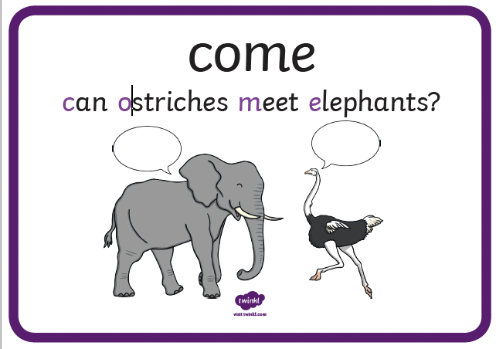 | 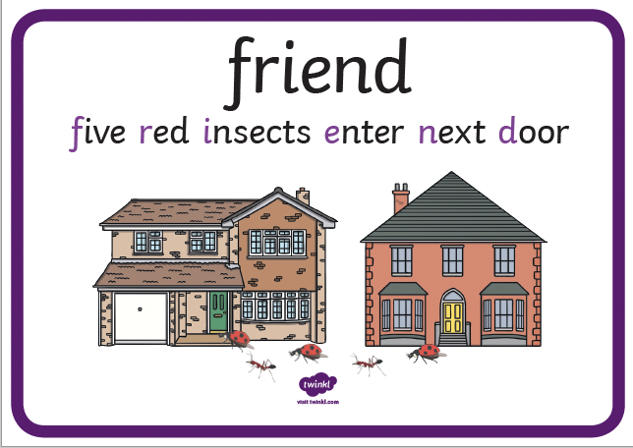 | 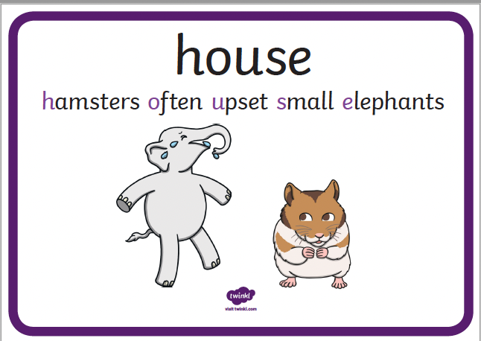 | 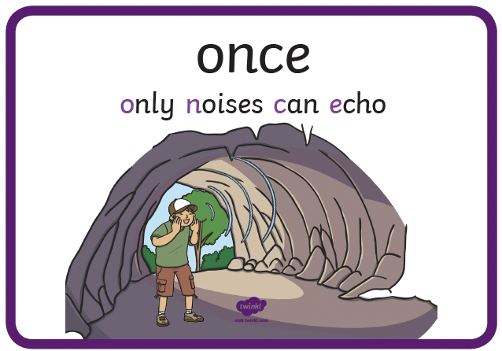
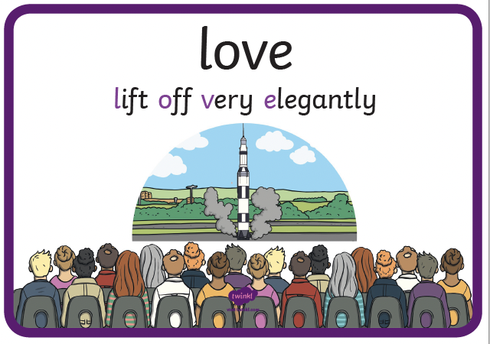 | 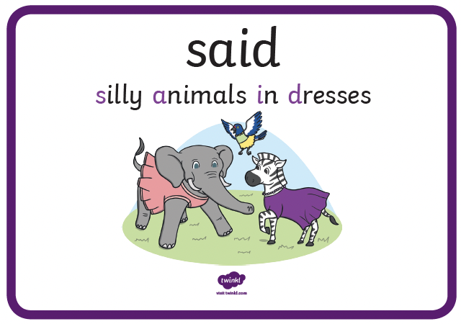 | 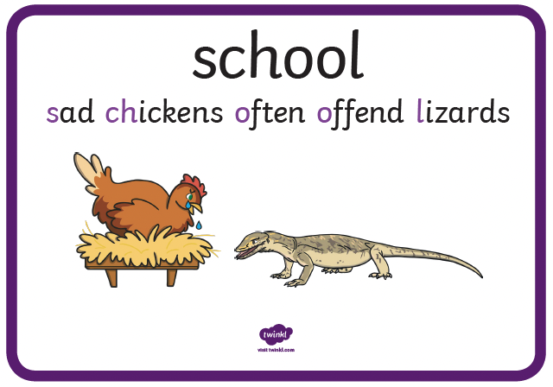 | 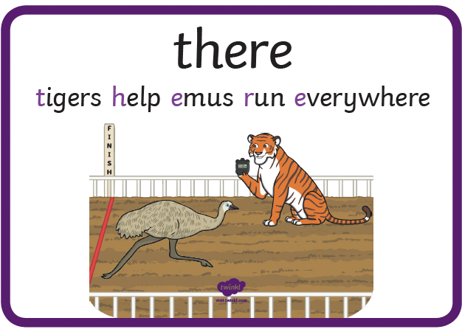
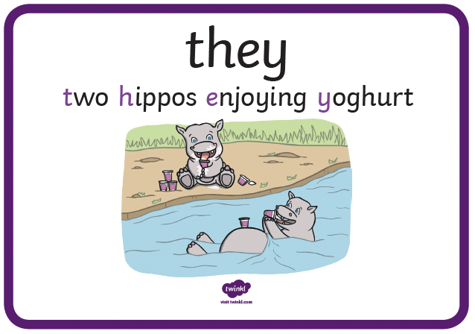 | 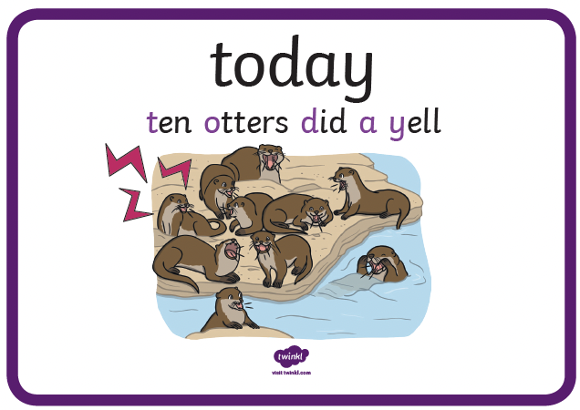 | 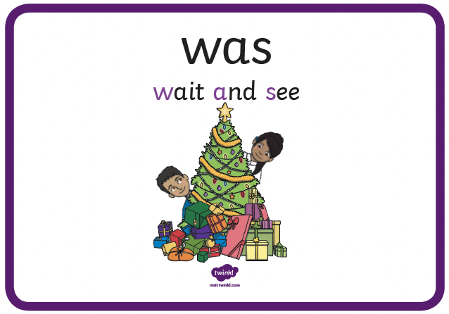 | 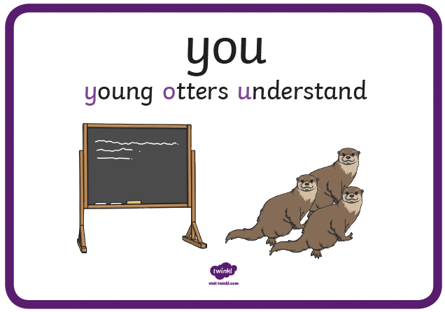
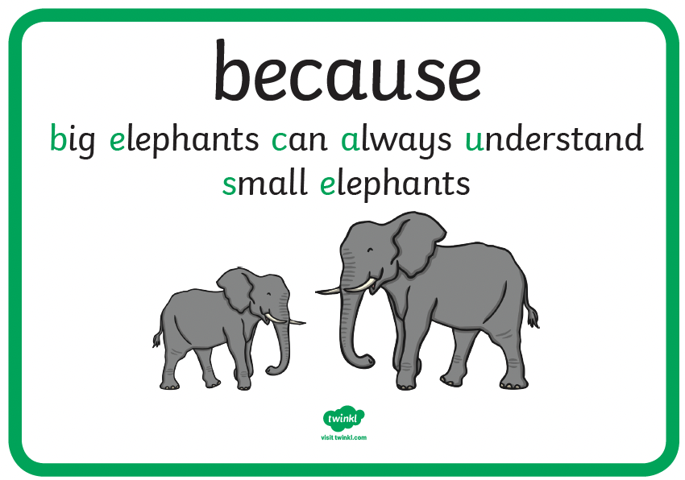 | 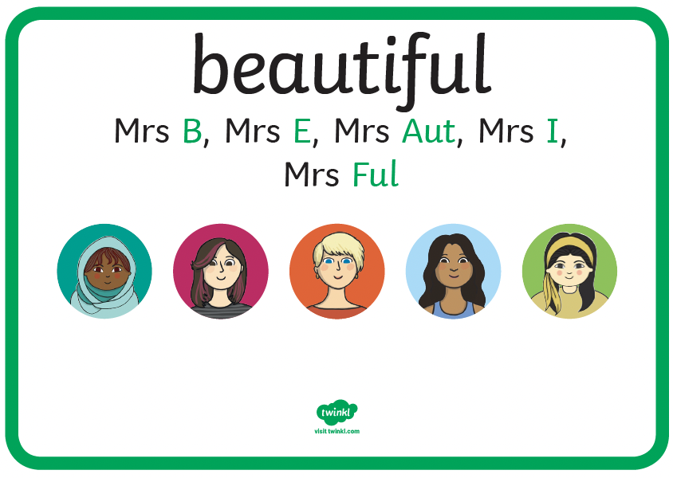 | 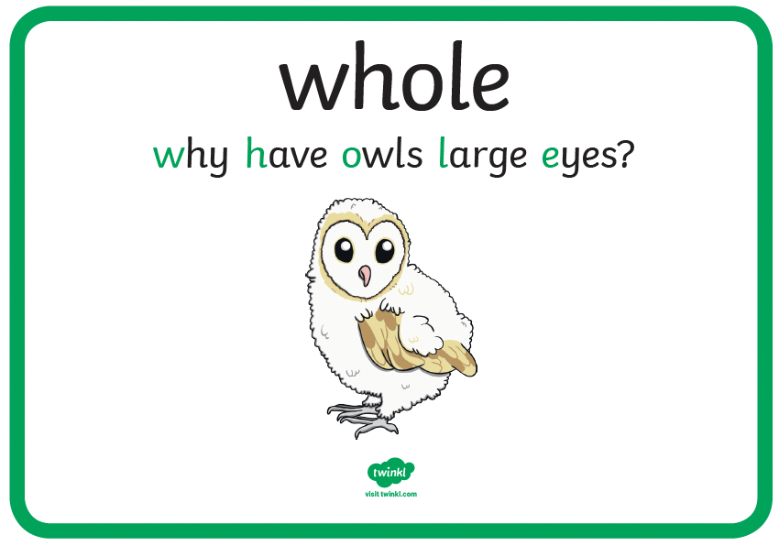 | 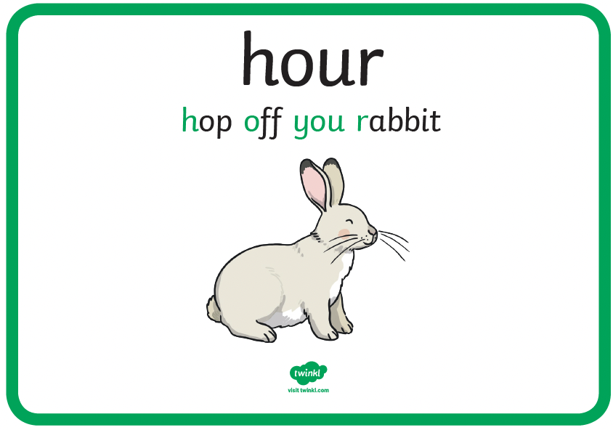
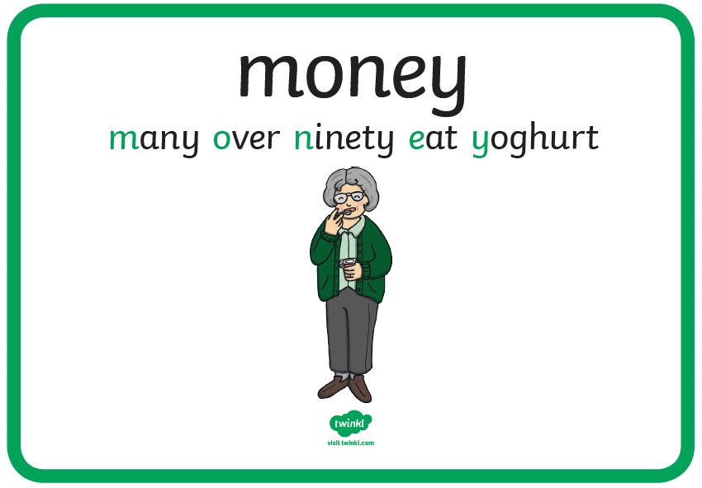 | 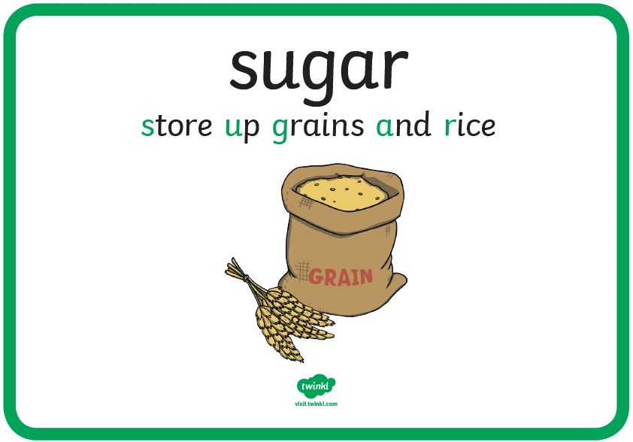 | 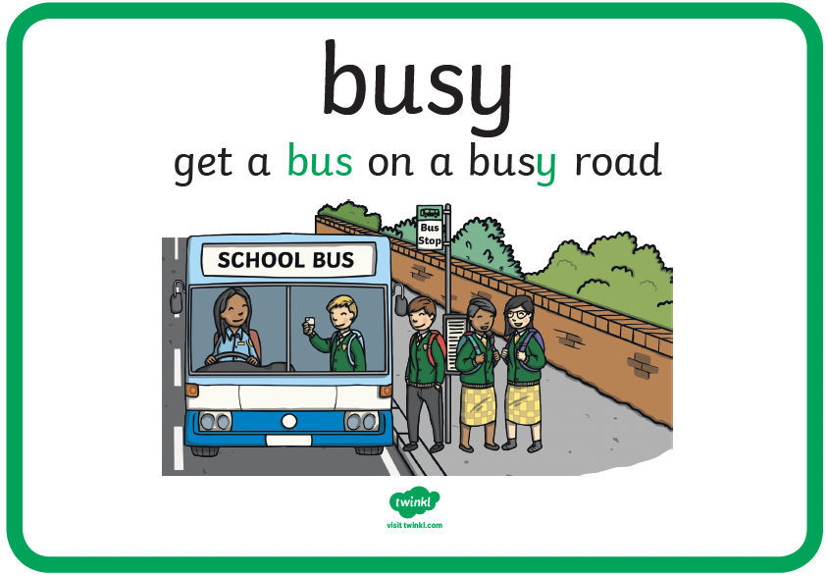 | 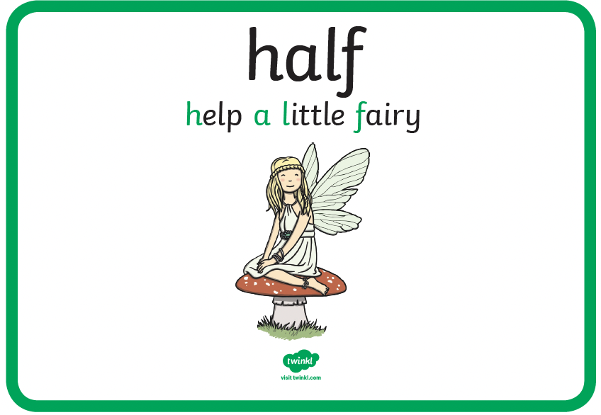
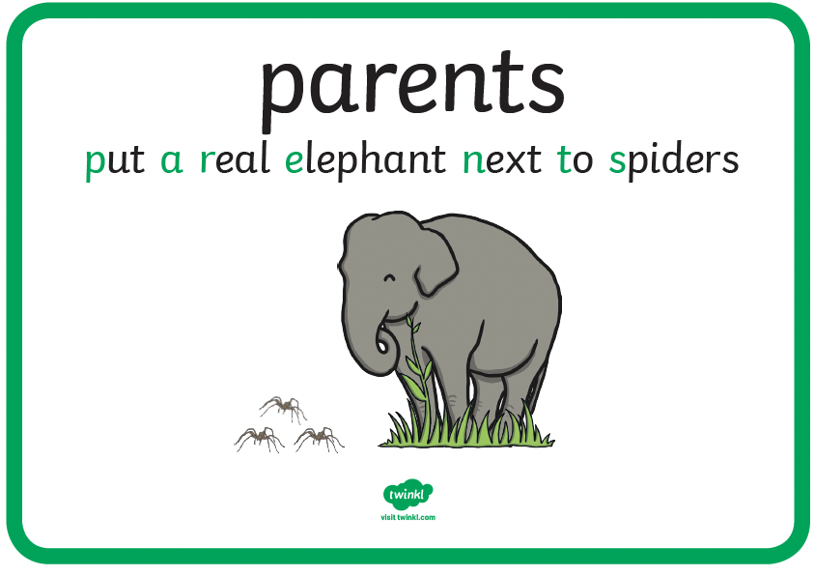 | 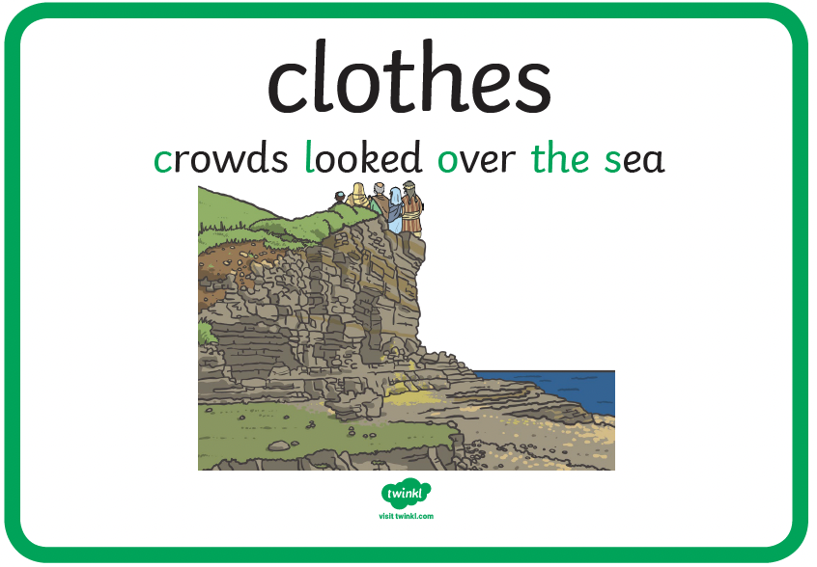 | 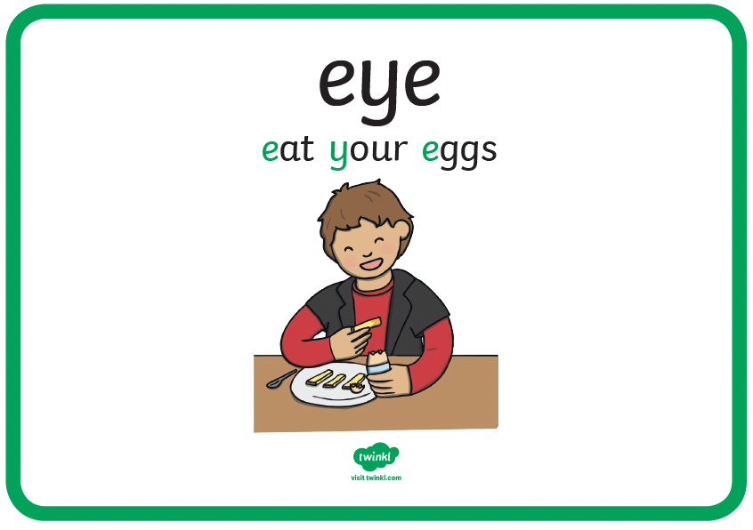 | 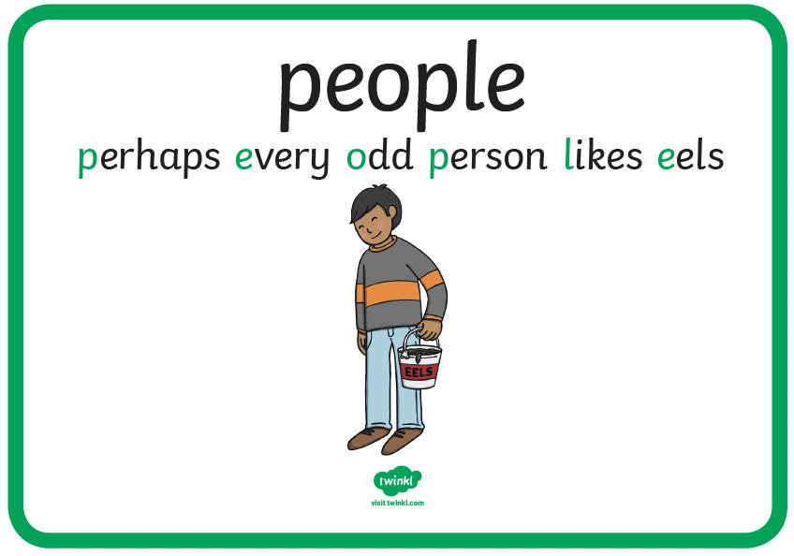

Autumn

Week 2 – 14th September - /u\ spelt ‘ou’

 | Monday | Tuesday | Wednesday | Thursday
touch
young
double
couple
trouble
country
cousin
enough
tough
rough

Week 3 – 21st September – ‘-sure’ and ‘-ture’

 | Monday | Tuesday | Wednesday | Thursday
pressure
closure
treasure
reassure
ensure
adventure
capture
creature
culture
future

Week 4 – 28th September - /a\ spelt ‘ei’, ‘ey’ and ‘eigh’

 | Monday | Tuesday | Wednesday | Thursday
vein
beige
reindeer
reign
obey
survey
prey
weight
eight
neighbour

Week 5 – 5th October - /a\ spelt ‘ei’, ‘ey’ and ‘eigh’

 | Monday | Tuesday | Wednesday | Thursday
they
grey
convey
deity
veil
rein
sleigh
eighteen
eighty
freight

Week 6 – 12th October – ‘-ation’ suffix

 | Monday | Tuesday | Wednesday | Thursday
nation
station
information
preparation
formation
organisation
observation
occupation
cancellation
recommendation

Week 7 – 19th October – ‘un-‘, ‘dis-‘ and ‘mis-‘ prefix

 | Monday | Tuesday | Wednesday | Thursday
unhappy
unkind
unhelpful
disappear
disinterest
disagree
disobey
misunderstand
mislead
misplace

Week 8 – 2nd November – ‘il-‘, ‘in-‘ and ‘ir-‘ prefix

 | Monday | Tuesday | Wednesday | Thursday
illegal
illegible
illogical
indirect
insecure
inactive
intolerant
irrelevant
irresponsible
irregular

Week 9 – 9th November – ‘re-‘ prefix

 | Monday | Tuesday | Wednesday | Thursday
redo
retry
reuse
reappear
return
renew
replay
rebuild
reread
rewrite

Week 10 – 16th November – ‘anti-‘ prefix

 | Monday | Tuesday | Wednesday | Thursday
antisocial
anticlockwise
antidote
anticlimax
antibiotic
antiseptic
antifreeze
antibody
antivirus
antihero

Week 11 – 23rd November – ‘sub-‘ and ‘super-‘ prefix

 | Monday | Tuesday | Wednesday | Thursday
submerge
submarine
subway
substitute
subheading
superstar
superpower
superstore
supernatural
supervise

Week 12 – 30th November – ‘auto-‘ prefix

 | Monday | Tuesday | Wednesday | Thursday
autograph
autobiography
automatic
autocorrect
autosave
autopilot
automobile
autocrat
autofocus
autotype

Spring

Week 1 – 4th January – ‘-tion’ suffix

 | Monday | Tuesday | Wednesday | Thursday
action
reaction
station
location
nation
ambition
position
direction
subtraction
addition

Week 2 – 11th January – ‘-tion’ and ‘-cian’ suffix

 | Monday | Tuesday | Wednesday | Thursday
solution
ambition
pollution
fiction
caution
magician
musician
electrician
politician
optician

Week 3 – 18th January – ‘-ssion’ and ‘-sion’ suffix

 | Monday | Tuesday | Wednesday | Thursday
discussion
percussion
possession
impression
confession
division
persuasion
conclusion
television
decision

Week 4 – 25th January – ‘-ous’ suffix

 | Monday | Tuesday | Wednesday | Thursday
enormous
generous
famous
dangerous
jealous
serious
obvious
courageous
curious
various

Week 5 – 1st February – ‘-ly’ suffix

 | Monday | Tuesday | Wednesday | Thursday
sadly
happily
brightly
angrily
gently
simply
truly
lately
firstly
lastly

Week 6 – 8th February – ‘-ly’ and ‘-ally’ suffix

 | Monday | Tuesday | Wednesday | Thursday
brightly
timidly
quickly
softly
harshly
basically
tragically
traditionally
frantically
finally

Week 7 – 22nd February - /k\ spelt ‘ch’

 | Monday | Tuesday | Wednesday | Thursday
character
echo
chorus
scheme
architect
monarch
stomach
chaos
chemist
school

Week 8 – 1st March - /s\ spelt ‘sc’

 | Monday | Tuesday | Wednesday | Thursday
science
fascinate
scientist
scene
scissors
scent
muscle
ascend
descend
scene

Week 9 – 8th March – ‘-gue’ and ‘-que’ suffix

 | Monday | Tuesday | Wednesday | Thursday
league
colleague
dialogue
prologue
vague
antique
unique
picturesque
plaque
cheque

Week 10 – 15th March – ‘-ing’, ‘-ed’ and ‘-er’ vowel suffix

 | Monday | Tuesday | Wednesday | Thursday
teacher
lighter
darker
lighter
washing
cleaning
drying
played
walked
listened

Summer

Week 1 – 19th April – plural possessive apostrophes

 | Monday | Tuesday | Wednesday | Thursday
children’s
men’s
women’s
teachers’
parents’
people’s
babies’
friends’
schools’
adults’

Week 2 – 26th April – plural possessive apostrophes

 | Monday | Tuesday | Wednesday | Thursday
dogs’
cats’
birds’
fathers’
mothers’
actors’
wolves’
ducklings’
trees’
rabbits’

Week 3 – 3rd May – homophones

 | Monday | Tuesday | Wednesday | Thursday
mail
male
mist
missed
prey
pray
main
mane
plain
plane

Week 4 – 10th May – homophones

 | Monday | Tuesday | Wednesday | Thursday
meet
meat
he’ll
heel
heal
there
their
they’re
past
passed

Week 5 – 17th May – homophones

 | Monday | Tuesday | Wednesday | Thursday
through
threw
groan
grown
herd
heard
write
right
would
wood

Week 6 – 28th June – CE words

 | Monday | Tuesday | Wednesday | Thursday
answer
appear
arrive
believe
breathe
build
caught
century
circle
continue

Week 7 – 5th July – CE words

 | Monday | Tuesday | Wednesday | Thursday
different
difficult
earth
eight
exercise
favourite
fruit
group
guide
height

Week 8 – 12th July – CE words

 | Monday | Tuesday | Wednesday | Thursday
interest
length
minute
natural
often
probably
question
remember
sentence
woman

